**Ideation Phase**

**Brainstorm&Idea Prioritization**

|  |  |
| --- | --- |
| Date | 19 September 2022 |
| Team ID | PNT2022TMID47104 |
| Project Name | Inventory Management System for Retailers |
| Maximum Marks | 4 Marks |

**Brainstorm & Idea Prioritization**

Reference:<https://app.mural.co/invitation/mural/inventorymanagementsystem0923/1663999065743?sender=uc8206468e212748e2eea2294&key=6cb9805a-42b7-42db-89f0-7900f1f71c90>

**Step-1: Team Gathering, Collaboration and Select the Problem Statement**

**Step-2: Brainstorm, Idea Listing and Grouping**

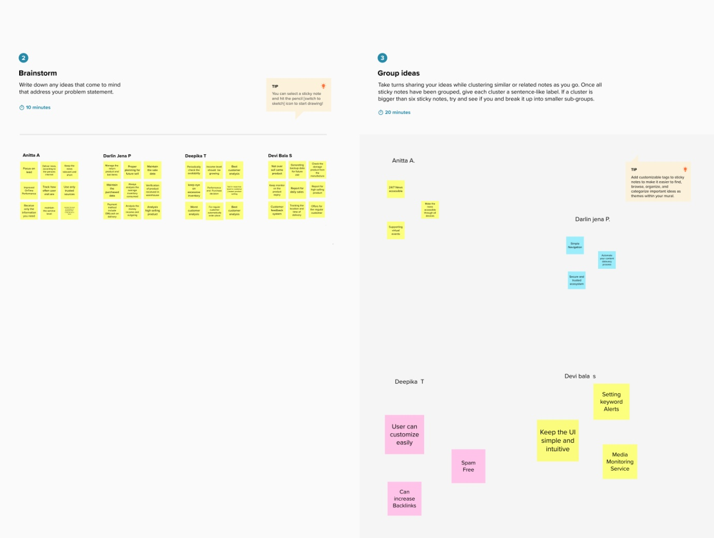

**Step-3: Idea Prioritization**

